Q. Write Pipeline script for clone project and build it on master and deploy the war on slaves.

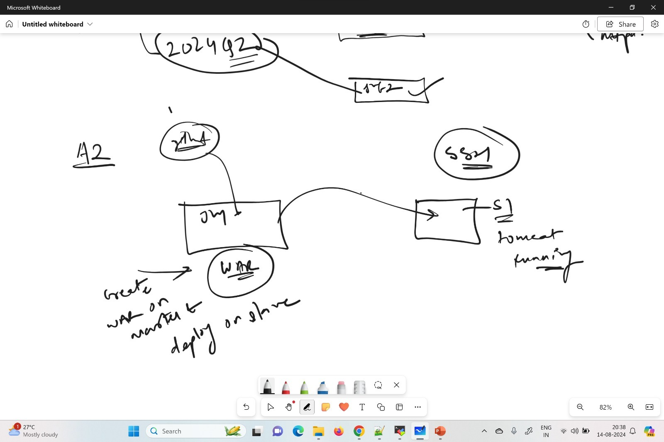

Launch 3 Ec2 instances (1 as master and 2 nodes)

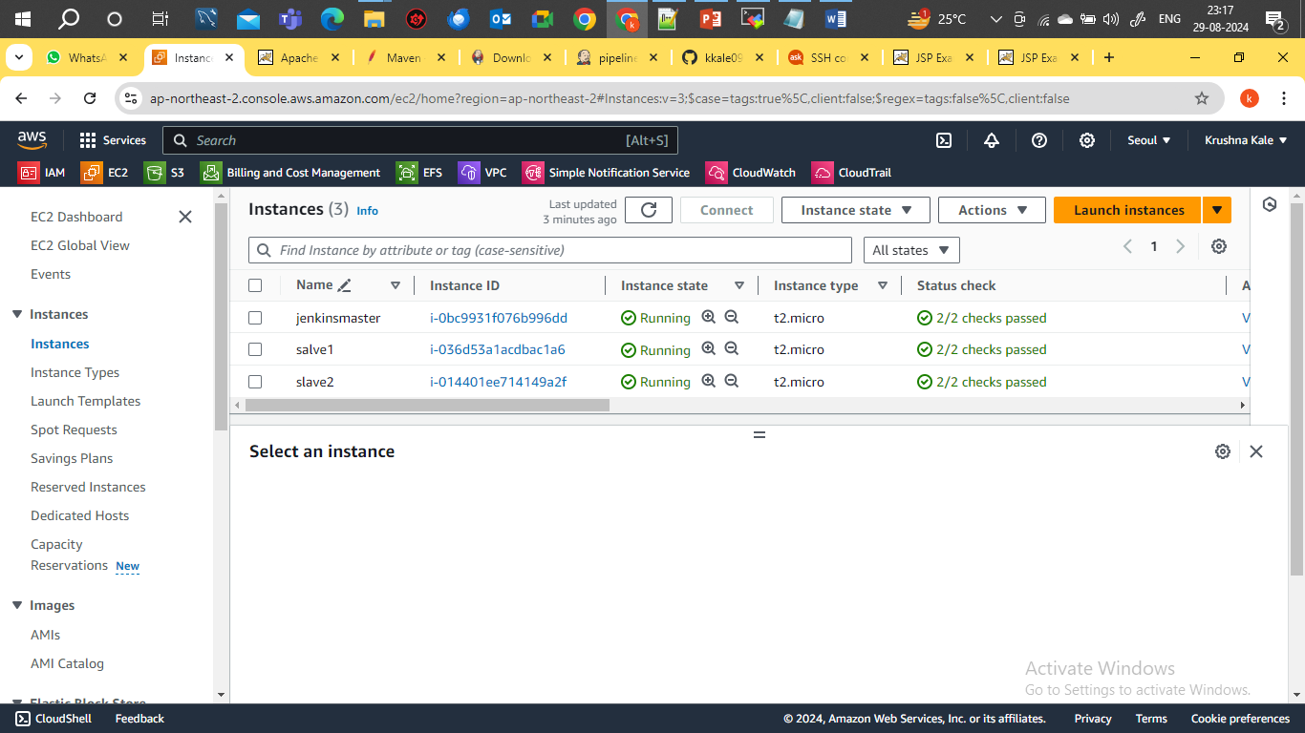

Create Jenkins-master and Slave Connection through SSH

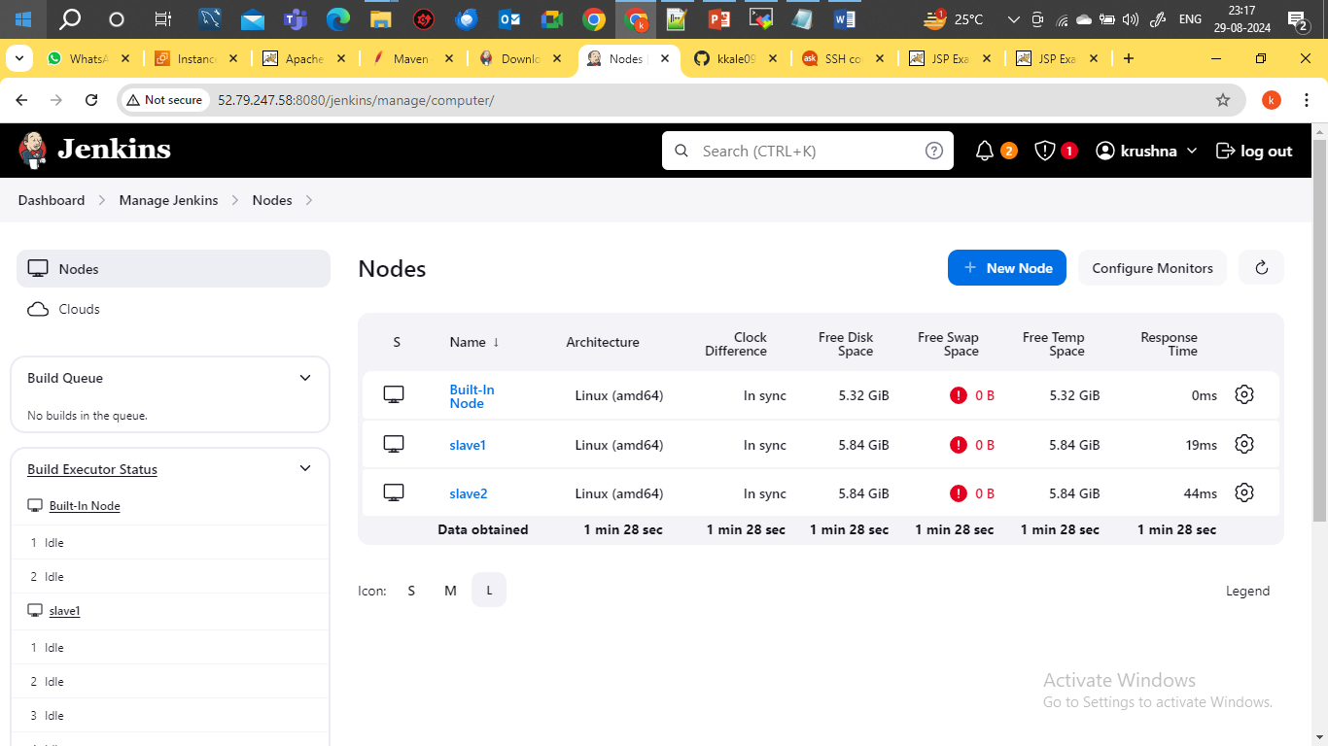

Create Pipeline Job which run on Master

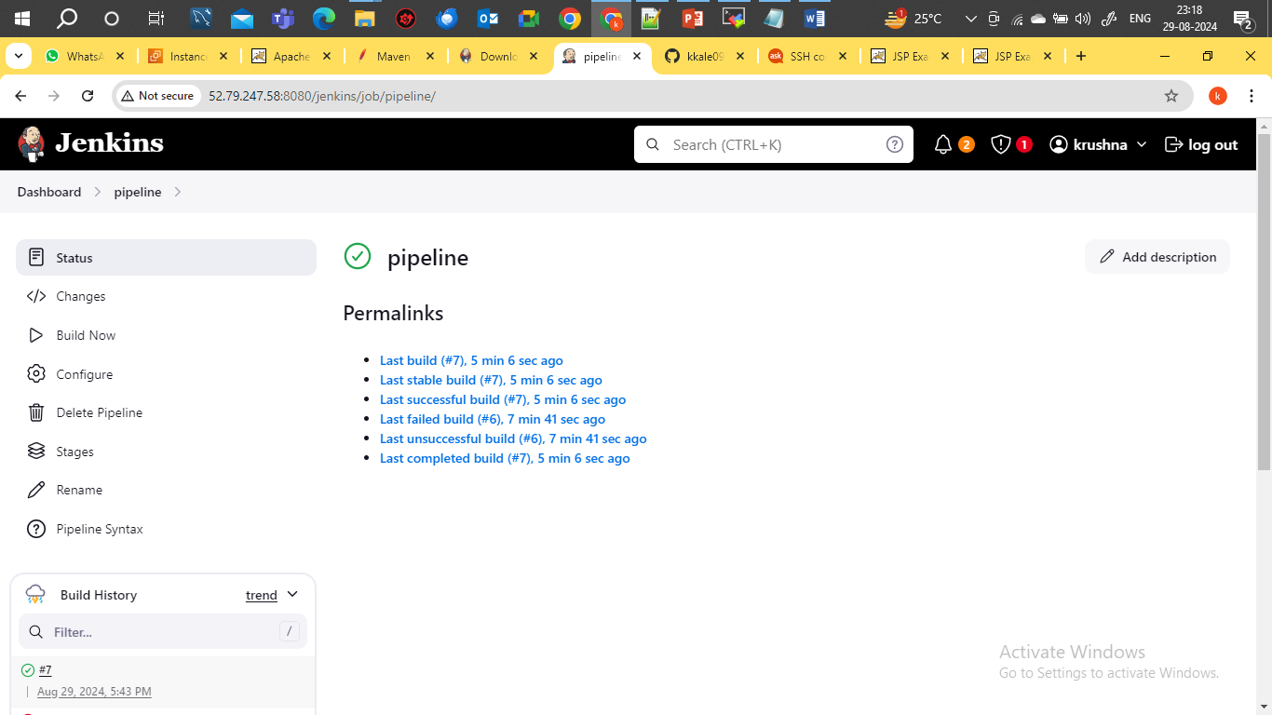

Write pipeline script to execute job

pipeline{

agent {

label{

label "built-in"

customWorkspace "/mnt"

}

}

tools {

maven 'apache-maven-3.9.9'

}

stages {

stage("clone_project"){

steps {

sh "rm -rf demoproject*"

sh "git clone https://github.com/kkale0901/demoproject.git"

}

}

stage("build_stage"){

agent {

label{

label "built-in"

customWorkspace "/mnt/demoproject"

}

}

steps{

sh "mvn clean install"

}

}

stage("deploy_war"){

steps{

sh"sudo scp -i Seoul-Linuc-kp.pem /mnt/demoproject/target/LoginWebApp.war ec2-user@172.31.2.121:/home/ec2-user/servers/apache-tomcat-9.0.93/webapps"

sh"sudo scp -i Seoul-Linuc-kp.pem /mnt/demoproject/target/LoginWebApp.war ec2-user@172.31.15.9:/home/ec2-user/servers/apache-tomcat-9.0.93/webapps"

}}}}

Job Build Successfully

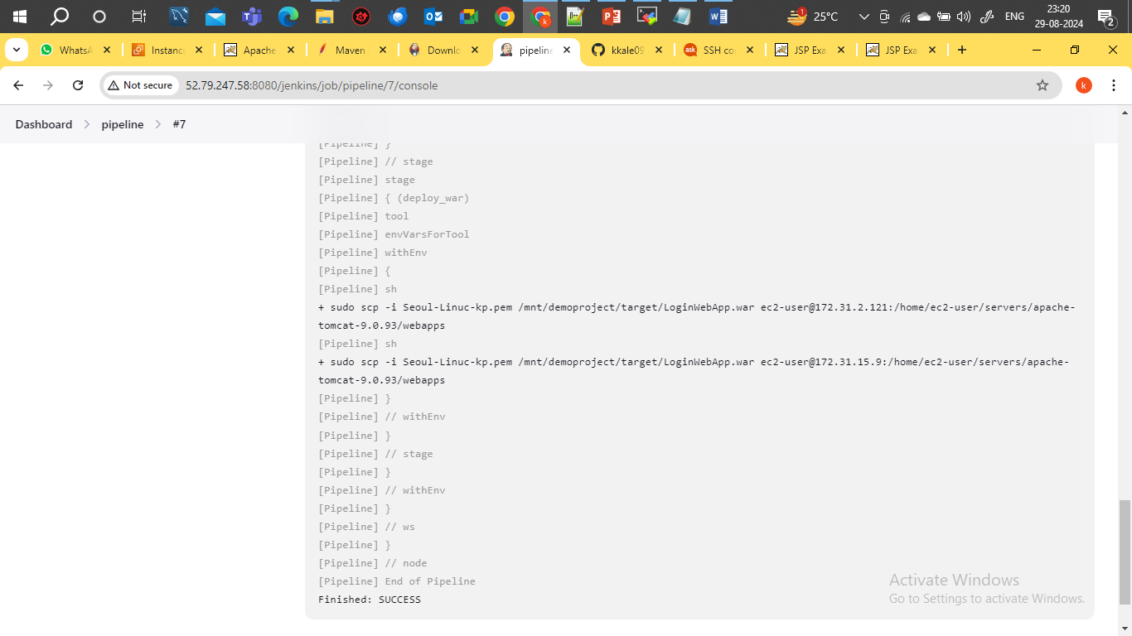

War hot on node (slave1)

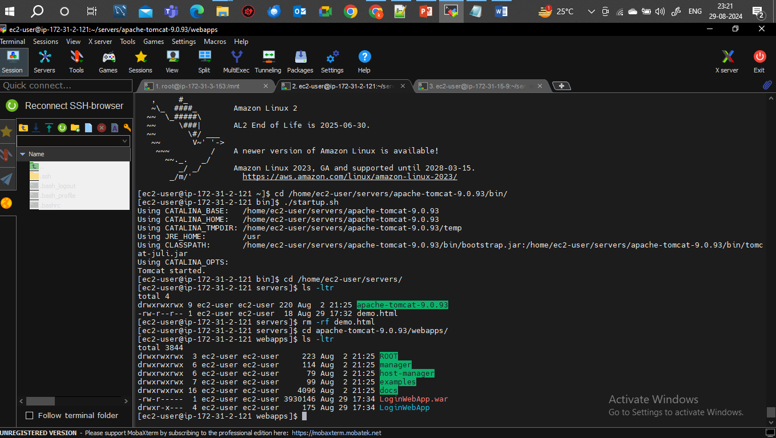

War hot on nodes (slave2)

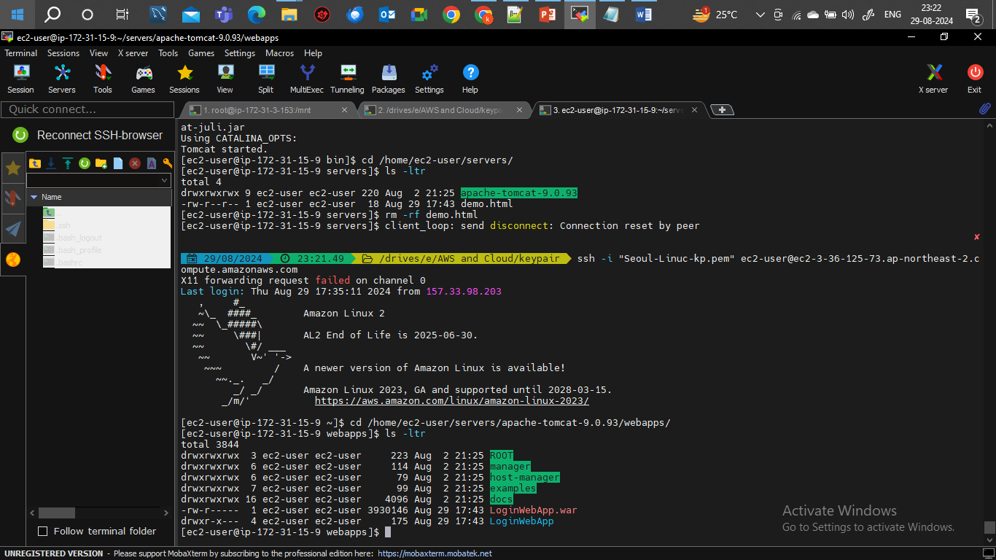

Confirm on browser

